Multiple-choice section

|  |  |  |  |  |  |  |  |  |
| --- | --- | --- | --- | --- | --- | --- | --- | --- |
| Question | 1 | 2 | 3 | 4 | 5 | 6 | 7 | 8 |
| Answer | D | A | C | D | D | A | A | D |

Question 1 [5.1]

D





3*a* = 12

*a* = 4

Question 2 [5.2]

A

Let *x* be number of girls in the class*.*

If the number of boys is one-third that of the girls, then there are *x* boys in the class.

The total number of students is therefore *x* +*x*.

There are 20 students in the class, so *x* +*x* = 20, or 3*x* + *x* = 60

Question 3 [5.3]

C

Let *A*(*x*1, *y*1) = (-3, -3) and *B*(*x*2, *y*2) = (4, 2)

*x*1 = -3, *x*2 = 4, *y*1 = -3, *y*2 = 2

Write the distance formula, substitute in the relevant values, and evaluate.



Question 4 [5.4]

D

*a* increases by 2 and *b* decreases by 6, so the multiplying factor is -3. *b* = 5 when *a* = 0, so 5 will be the constant that is added after *a* is multiplied.

*b* = -3*a* + 5

Check by substituting a pair of values from the table.

If *a* = 2:

*b* = -3 × 2 + 5

= -6 + 5

= -1

Question 5 [5.5]

D

*m* = 

= 

Consider the points (0, 3) and (3, -1).

Let *x*1 = 0, *x*2 = 3, *y*1 = 3, *y*2 = -1



Question 6 [5.6]

A

The gradient of the initial line is .

The gradient of the perpendicular line is the negative reciprocal of this: 

Question 7 [5.7]

A

2*x* − 3*y* = 12

When *y* = 0:

2*x* − (3 × 0) = 12

2*x* = 12

*x* = 6

∴ *x*-intercept = (6, 0)

Calculate the *y*-intercept by substituting *x* = 0 and solving the equation.

2*x* − 3*y* = 12

When *x* = 0

(2 × 0) − 3*y* = 12

-3*y* = 12



*y* = -4

∴ *y*-intercept = (0, -4)

Question 8 [5.8]

D

The vertical line *x* = 3 has an undefined gradient.

The horizontal line *y* = -2 has zero gradient.

The lines are *x* = 3 and *y* = -2.

Multiple-choice total marks: 8

Short answer section

Question 9 3 marks [5.1]



Question 10 3 marks [5.2]

Let *a* be David’s age. Greg is three times David’s age, so let 3*a* be Greg’s age.

In 10 years’ time, David’s age will be *a* + 10. Greg’s age will be 3*a* + 10.

*a* + 10 + 3*a* + 10 = 72

4*a* + 20 = 72

4*a* = 52

*a* = 13

So, David’s age currently is 13, and Greg’s age is 3 × 13 = 39.

Question 11 5 marks [5.3]

(a) *AC*: 

*BC*: 

*AB*: 

(b) This is a 3, 4, 5 triangle so it is a right-angled scalene triangle.

(c) 

Question 12 4 marks [5.4]

(a)

|  |  |  |  |  |  |
| --- | --- | --- | --- | --- | --- |
| T | -2 | -1 | 0 | 1 | 2 |
| P | -1 |  |  | 1 |  |

**(b)**

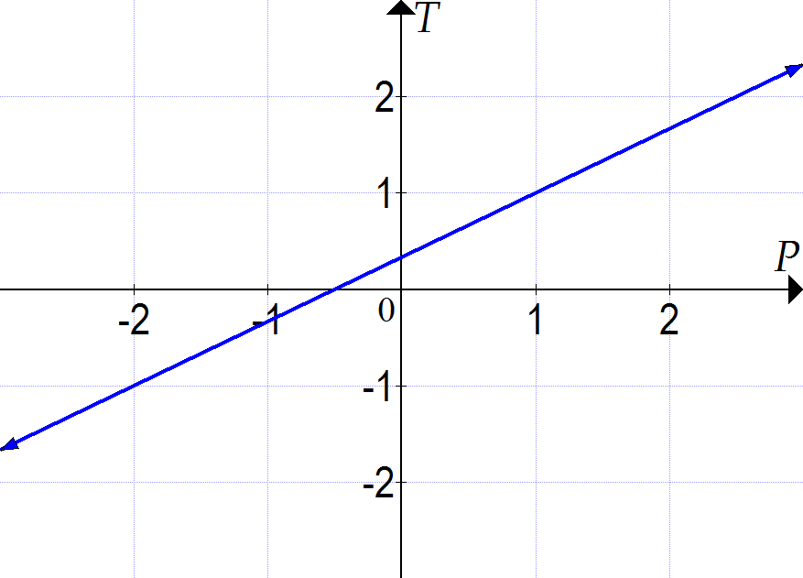

Question 13 4 marks [5.5]

*m* = 

= 

Substitute values into the rule and evaluate for each line segment.

*a*: (2, 1), (-2, -2) *b*: (-2, 0), (1, -4) *c*: (-1, 1), (2, -2) *d*: (-1, 1), (-2, -3)

|  |  |
| --- | --- |
| Line segment *a*:  *x*1 = 2, *x*2 = -2, *y*1 = 1, *y*2 = -2 | Line segment *b*:  *x*1 = -2, *x*2 = 1, *y*1 = 0, *y*2 = -4 |
| Line segment *c*:  *x*1 = -1, *x*2 = 2, *y*1 = 1, *y*2 = -2 | Line segment *d*:  *x*1 = -1, *x*2 = -2, *y*1 = 1, *y*2 = -3 |

(a) The line segment with the greatest *positive* gradient is *d. m* = 4

(b) The line segment with the greatest *negative* gradient is *b.* 

Question 14 3 marks [5.6]



Therefore *m* =  and *c* = -2.

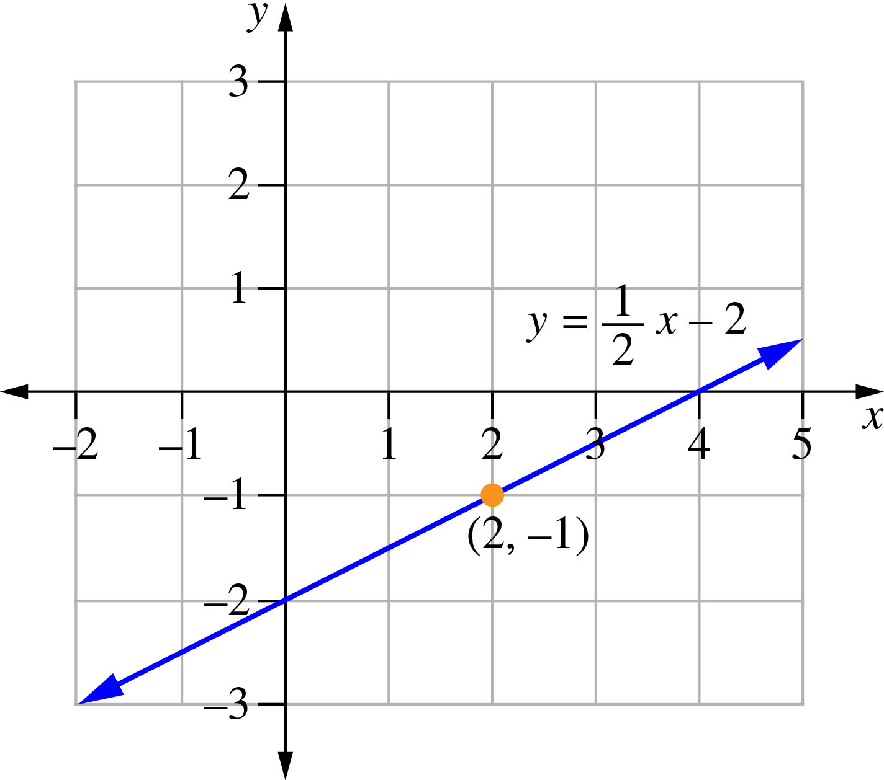

Question 15 3 marks [5.7]

Calculate the *x*-intercept by substituting *y* = 0 and solving the equation.

4*x* − 3*y* − 12 = 0

When *y* = 0:

4*x* − (3  0) − 12 = 0

4*x* − 12 = 0

4*x* = 12

*x* = 3

∴ *x*-intercept = (3, 0)

Calculate the *y*-intercept by substituting *x* = 0 and solving the equation.

4*x* − 3*y* − 12 = 0

When *x* = 0:

0 − 3*y* − 12 = 0

-3*y* = 12



*y* = -4

∴ *y*-intercept = (0, -4)

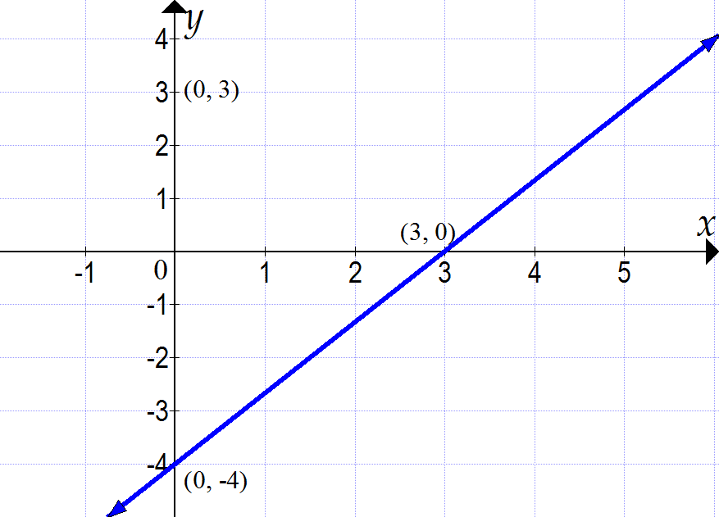

Question 16 2 marks [5.8]

(a) *y* = 2

(b) *x* = -3

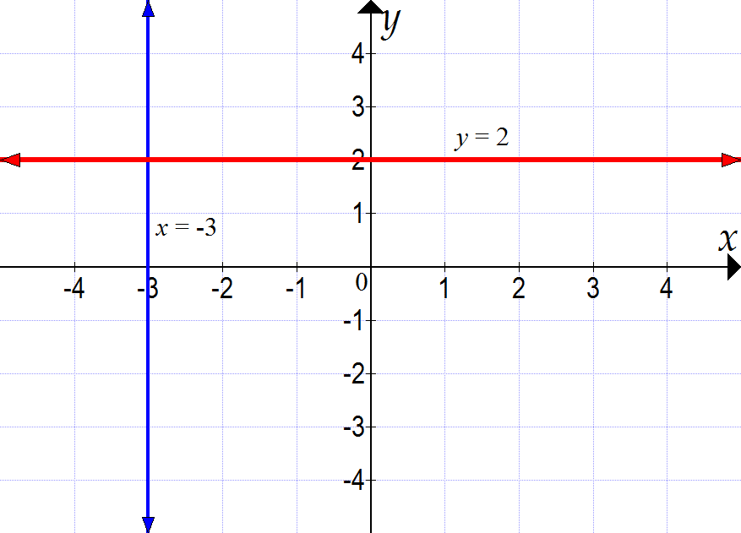

Short answer total marks: 27

Extended answer section

Question 17 5 marks [5.4, 5.5, 5.6, 5.7]

*y* = 2*x* + 3 is a linear equation in the form *y* = *mx* + *b*. The graph of the equation is a straight line, where *m* is the gradient and *b* is the *y*-intercept. To draw the graph, only two points are needed. Start at the *y*-intercept (0, 3) and use the gradient to find the next point. *m* = 2 means that rise = 2 and run = 1, so you should move up 2 and across 1 to find another point on the line: (1, 5). Repeat this to find a third point: (2, 7).

Alternatively, the *x*-intercept can be found by substituting *y* = 0 into the equation:

2*x* + 3 = 0

2*x* = -3

*x* = , so *x*-intercept = (, 0). Use this and the *y*-intercept of (0, 3) to plot the graph.

Question 18 10 marks [5.2, 5.3]

(a) *AB*: 

*AD*: 

*CD*: 

*BC*: 

(b) *AC*: 

*BD*: 

(c) All sides are the same length but the two diagonals have different lengths. Therefore, the shape is a rhombus.

(d) midpoint *AC*:  = (5, 5)

midpoint *BD*:  = (5, 5)

**(e)** The midpoints of the diagonals coincide.

Question 19 10 marks [5.2, 5.3]

(a)

|  |  |  |  |  |  |  |  |  |  |
| --- | --- | --- | --- | --- | --- | --- | --- | --- | --- |
| Number of books/reader | 0 | 1 | 2 | 3 | 4 | 5 | 6 | 7 | 8 |
| Axel | 0 | 1.5 | 3 | 4.5 | 6 | 7.5 | 9 | 10.5 | 12 |
| Brandon | 3 | 4 | 5 | 6 | 7 | 8 | 9 | 10 | 11 |
| Clarissa | 10 | 10 | 10 | 10 | 10 | 10 | 10 | 10 | 10 |

(b)

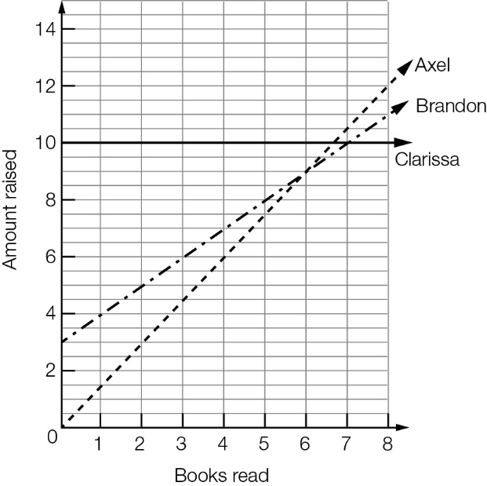

(c) No, they never collect the same amount, as there is no point at which all three lines intersect.

(d) (i) 7 or more books

(ii) never

(iii) 6 or fewer books

Extended answer total marks: 25

TOTAL test marks: 60